SIMATS ENGINEERING
ASSESSMENT TOOL 1
COURSE NAME: Database Management Systems
COURSE CODE: CSA05

COURSE OUTCOME COVERED

CO2: Apply the relational model, relational algebra, SQL query structures, and views to solve database querying and data manipulation problems. (BL3, BL6)

Activity Tool : Analytical Problem Solving (High)
Assessment Tool Weightage: 40%

QUESTIONS
Q.N o | Question | Bloom's Level
1 | Given a set of relations and sample data, write SQL queries to retrieve specific information using joins and subqueries, and explain the logic used.  Bloom’s Level: BL3 – Apply | BL4 – Analyze
2 | Using relational algebra, formulate expressions to solve complex queries such as retrieving records that satisfy multiple conditions across relations.  Bloom’s Level: BL4 – Analyse | BL5 – Evaluate
3 | Given a real-world scenario (e.g., banking or student system), design a relational schema and construct appropriate SQL queries for data retrieval and updates.  Bloom’s Level: BL6 – Create | BL6 – Create
4 | Analyse a given SQL query with nested subqueries and predict its output, explaining each step of execution.  Bloom’s Level: BL4 – Analyze | BL6 – Create
5 | Compare different SQL approaches (joins vs subqueries) for solving the same problem and evaluate their efficiency.  Bloom’s Level: BL5 – Evaluate | BL4 – Analyze
6 | Design and implement views for a database system to provide restricted data access, and justify their use for security and abstraction. Bloom’s Level: BL6 – Create | BL5 – Evaluate
7 | Given a database schema, write relational algebra expressions and convert them into equivalent SQL queries, analyzing differences in representation.  Bloom’s Level: BL4 – Analyze | BL4 – Analyze
8 | Optimize a set of inefficient SQL queries by restructuring them using joins, indexing concepts, or views, and evaluate performance improvements.  Bloom’s Level: BL5 – Evaluate | BL5 – Evaluate
9 | Develop a complex SQL query involving grouping, aggregation, and nested queries to solve a real-world problem.  Bloom’s Level: BL6 – Create | BL6 – Create
10 | Given multiple relations, analyze the query requirements and decide whether to use views, joins, or subqueries, justifying your choice with reasoning.  Bloom’s Level: BL5 – Evaluate | BL5 – Evaluate

Code of Conduct:

I _____M.sharmila(192572139)___________ (Name / Reg No) certify that this submission is my original work and that I have adhered to the guidelines specified for this assessment. I understand that any violation of academic integrity rules will result in disciplinary action.

Signature of the student:

- Given a set of relations and sample data, write SQL queries to retrieve specific information using joins and subqueries, and explain the logic used.

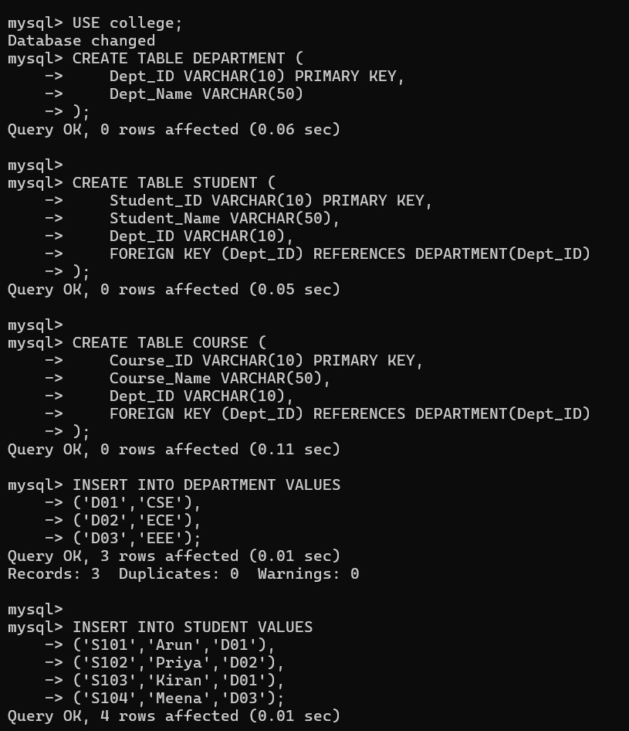

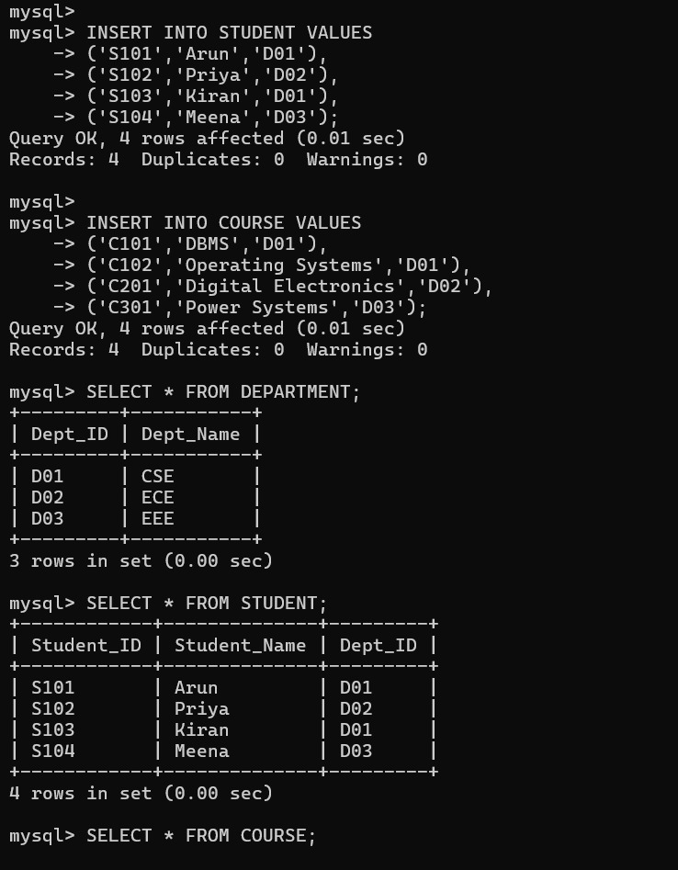

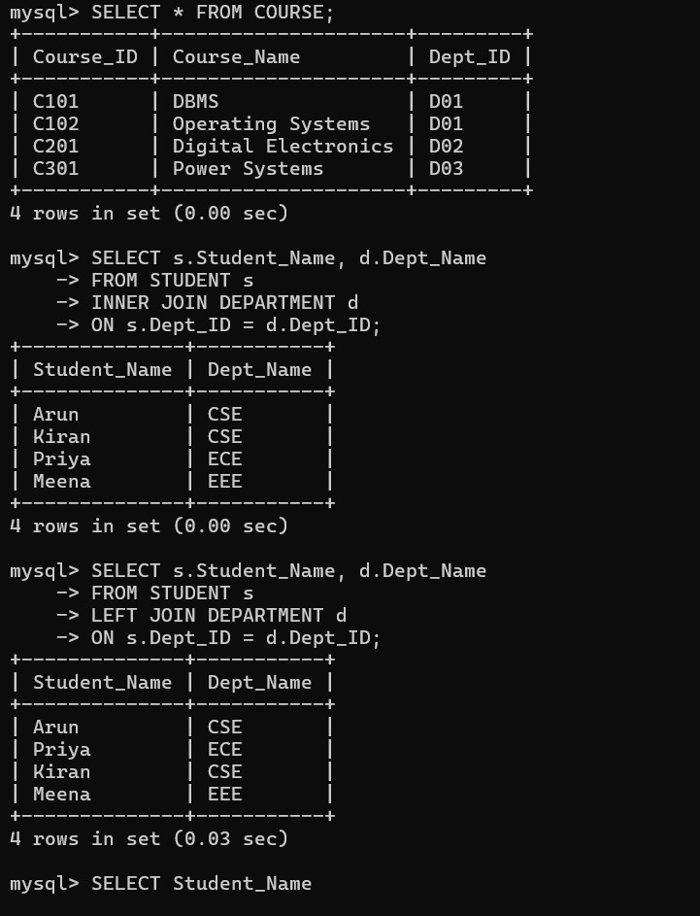

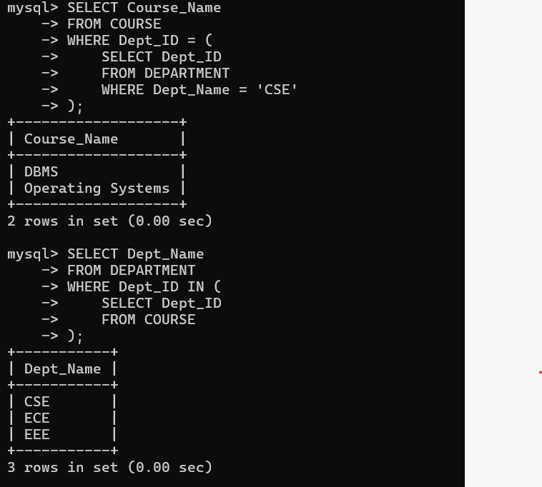

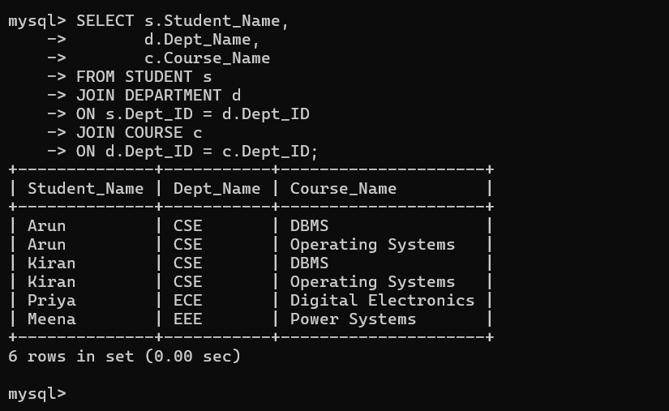

- Using relational algebra, formulate expressions to solve complex queries such as retrieving records that satisfy multiple conditions across relations.

Relations
- Student(StudentID, Name, Department)
- Marks(StudentID, Subject, Marks)
SQL Query
SELECT Student.Name
FROM Student
INNER JOIN Marks
ON Student.StudentID = Marks.StudentID
WHERE Student.Department = 'CSE'
AND Marks.Marks > 80;
Step 1: Join Operation
Student ⨝ Student.StudentID = Marks.StudentID Marks
Step 2: Selection Operation
σ Department = 'CSE' ∧ Marks > 80
(Student ⨝ Student.StudentID = Marks.StudentID Marks)
Step 3: Projection Operation
π Name
(
σ Department = 'CSE' ∧ Marks > 80
(Student ⨝ Student.StudentID = Marks.StudentID Marks)
)
Final Relational Algebra Expression
π Name (σ Department = 'CSE' ∧ Marks > 80
(Student ⨝ Student.StudentID = Marks.StudentID Marks))
Result
The required records satisfying multiple conditions across the Student and Marks relations are retrieved successfully using the Relational Algebra operators Selection (σ), Projection (π), and Join (⨝).
This is the proper line-by-line format that is typically expected in a DBMS practical record.


3.Given a real-world scenario (e.g., banking or student system), design a relational schema and construct appropriate SQL queries for data retrieval and updates.

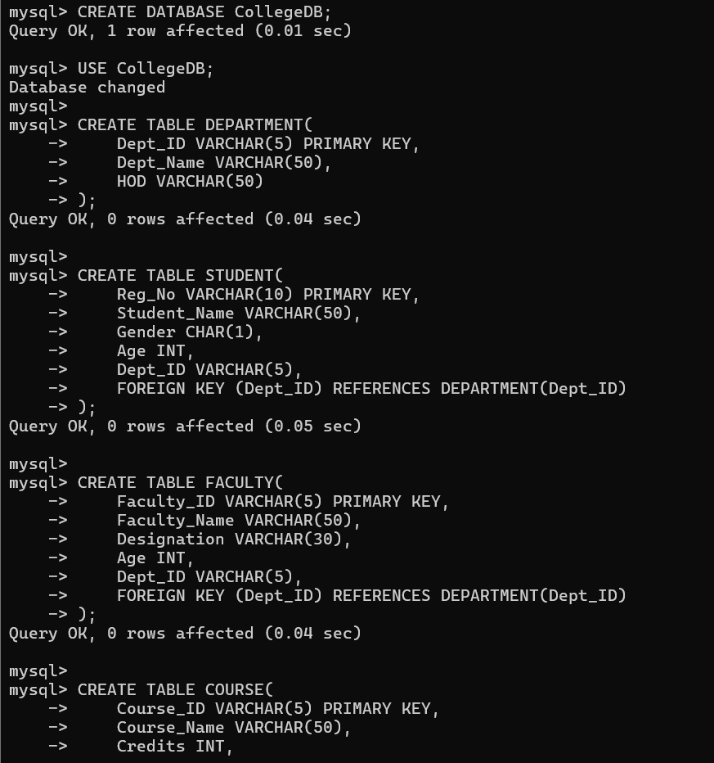

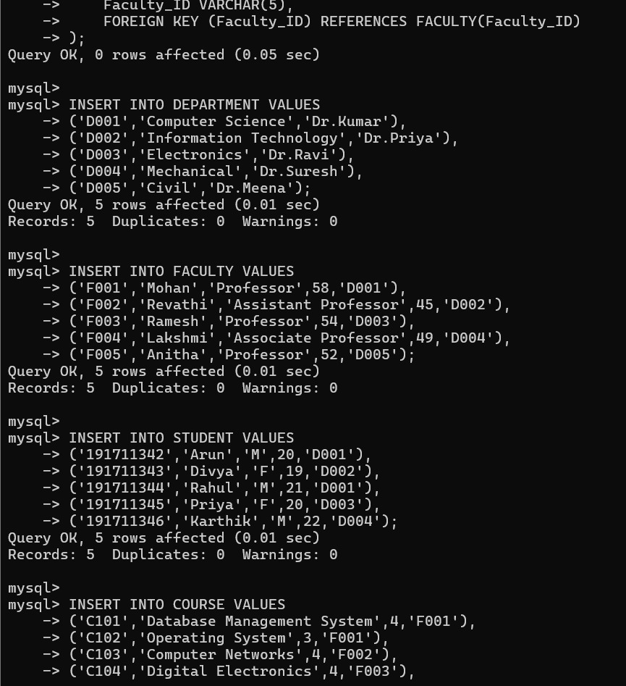

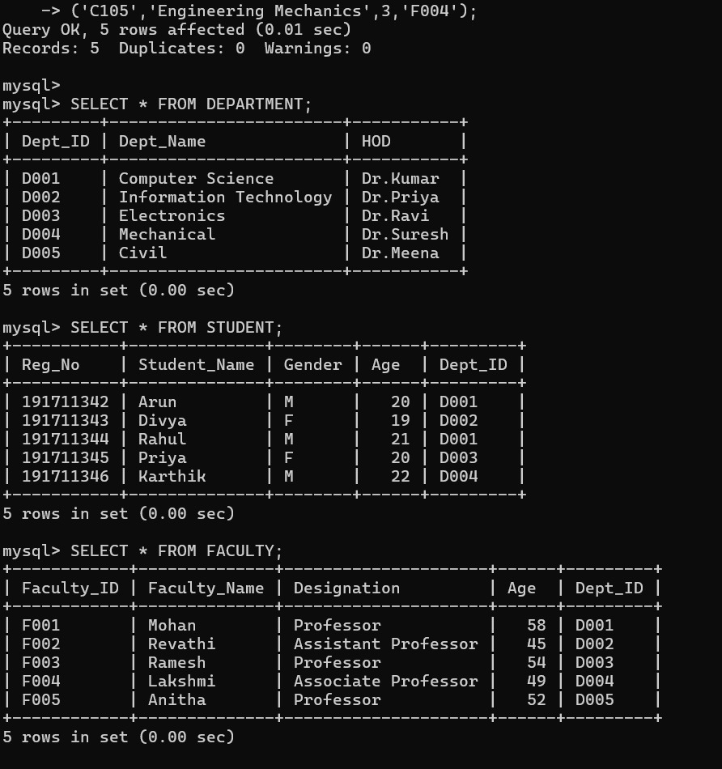

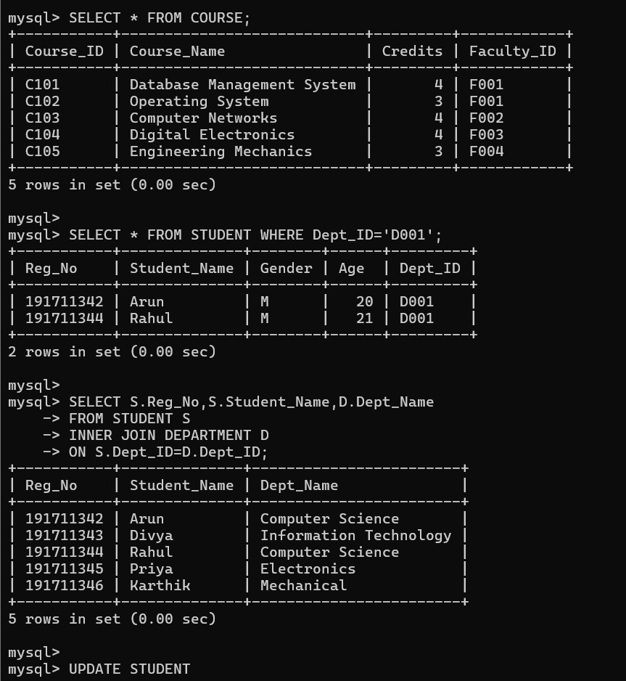

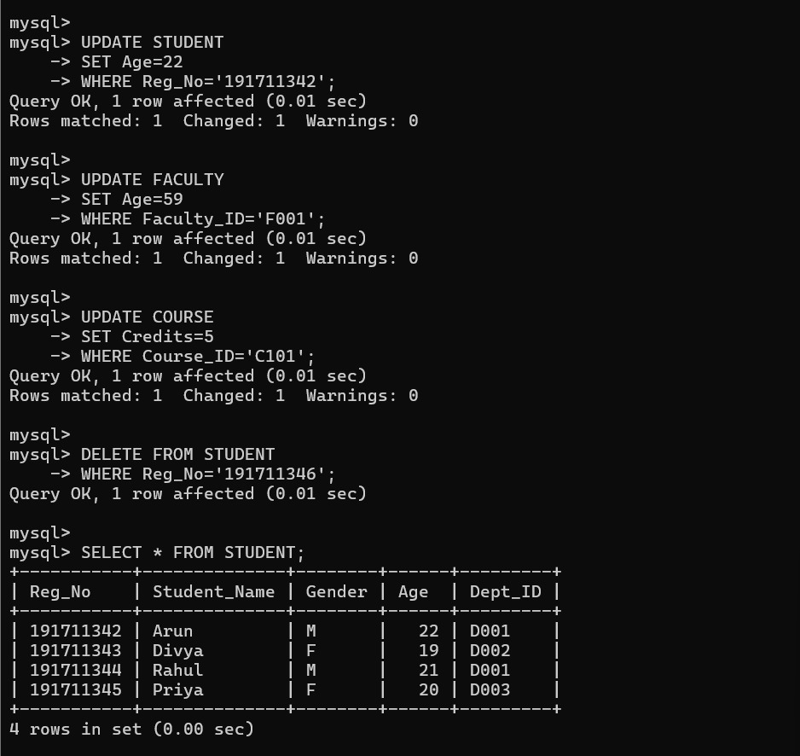

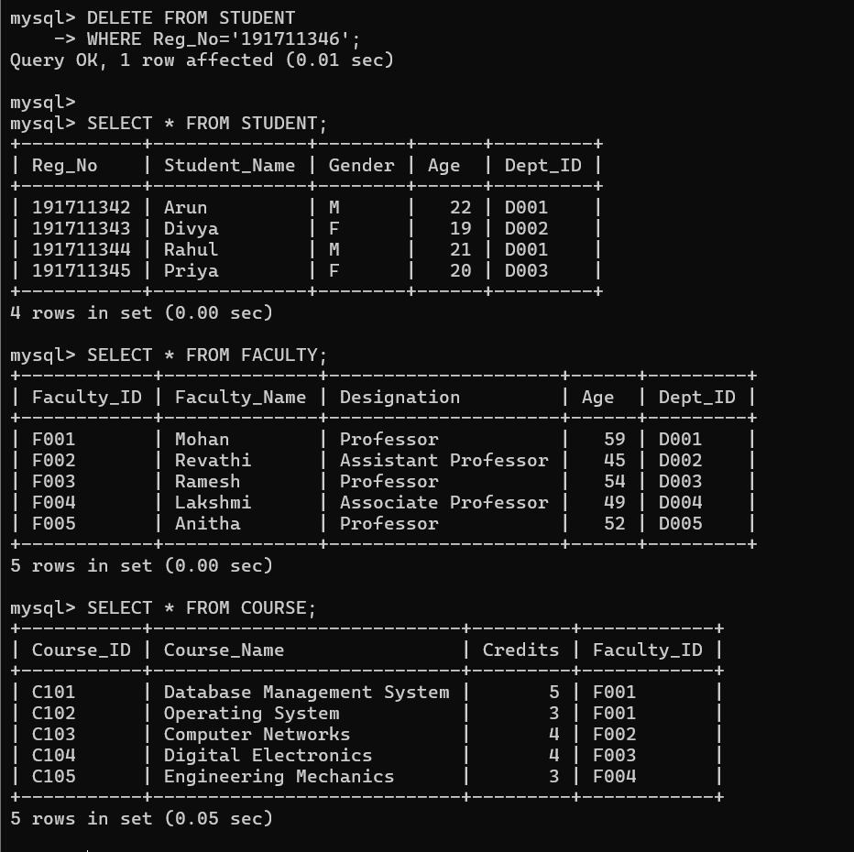

4.Analyse a given SQL query with nested subqueries and predict its output, explaining each step of execution.

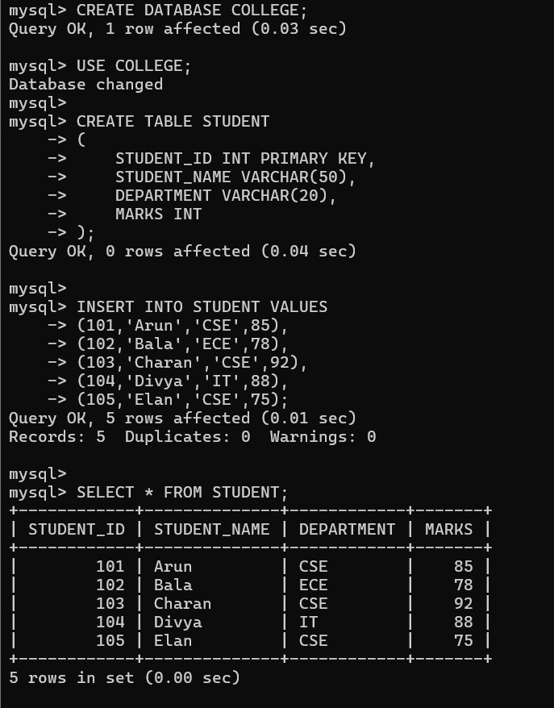

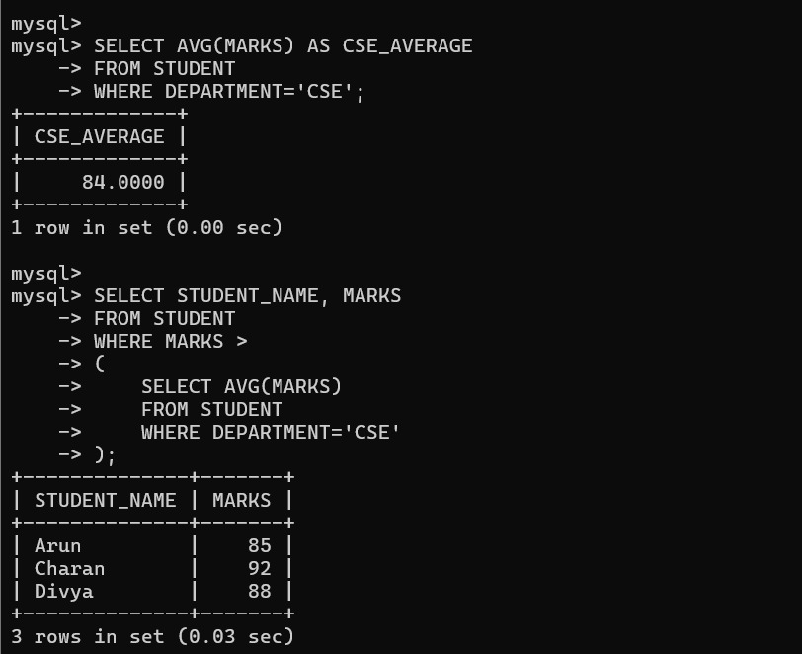

5.Compare different SQL approaches (joins vs subqueries) for solving the same problem and evaluate their efficiency

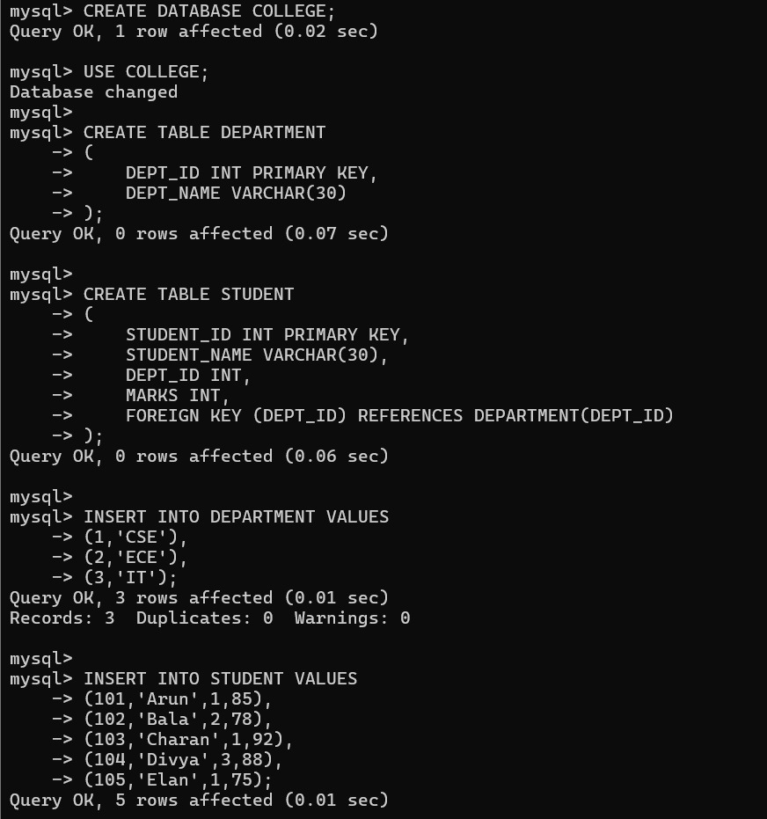

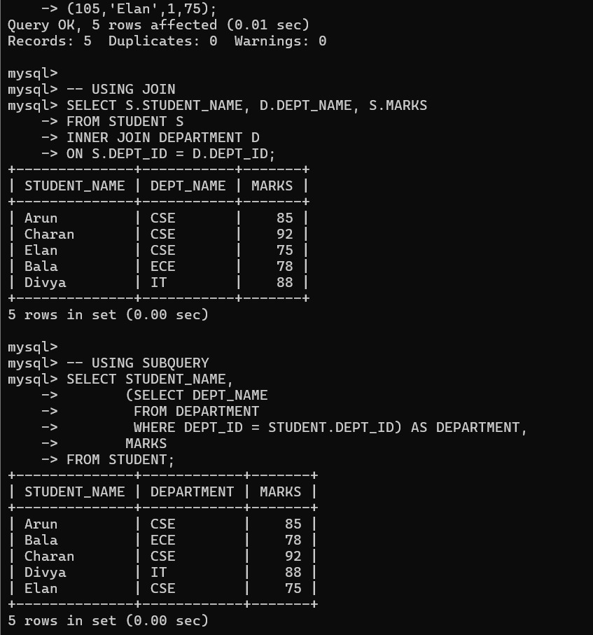

6.Design and implement views for a database system to provide restricted data access, and justify their use for security and abstraction.

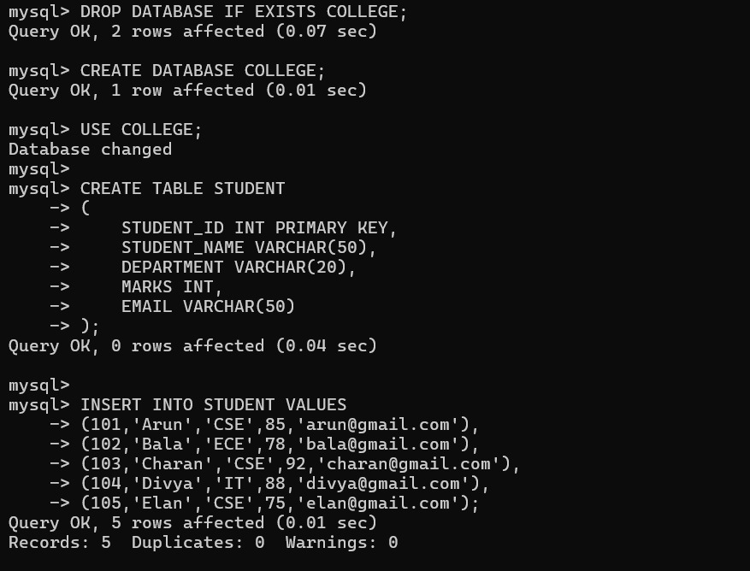

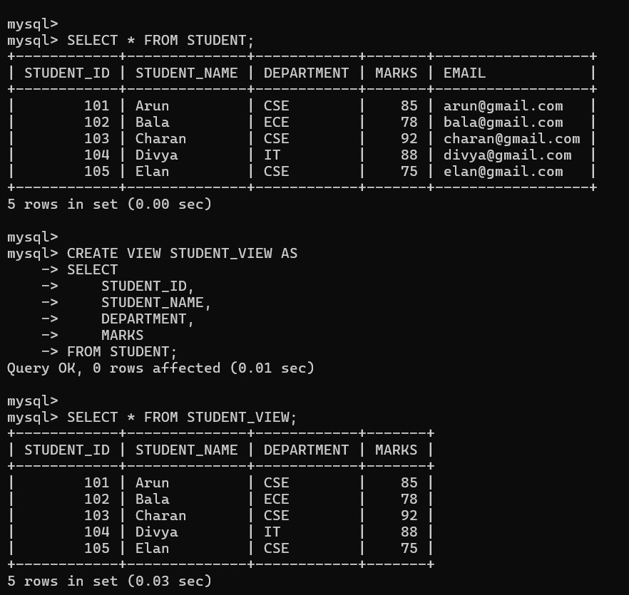

7.Given a database schema, write relational algebra expressions and convert them into equivalent SQL queries, analyzing differences in representation.
Relations
Student(StudentID, Name, Department)
Marks(StudentID, Subject, Marks)
Query
Retrieve the names of students who belong to the CSE department and scored more than 80 marks.
Relational Algebra Expression
π Name
(
σ Department='CSE' ∧ Marks>80
(
Student ⨝ Student.StudentID = Marks.StudentID Marks
)
)

Equivalent SQL Query
SELECT Student.Name
FROM Student
INNER JOIN Marks
ON Student.StudentID = Marks.StudentID
WHERE Student.Department = 'CSE'
AND Marks.Marks > 80;

Difference Between Relational

Algebra and SQL
Relational Algebra | SQL
Uses symbols such as π, σ, and ⨝ | Uses keywords like SELECT, FROM, WHERE, JOIN
Procedural query language | Declarative query language
Describes how to retrieve data | Describes what data to retrieve
Used for theoretical representation | Used for implementation in DBMS

RESULT
The Relational Algebra expression was successfully converted into an equivalent SQL query. Both produce the same output, but Relational Algebra uses mathematical notation while SQL uses English-like commands.

8.Optimize a set of inefficient SQL queries by restructuring them using joins, indexing concepts, or views, and evaluate performance improvements.

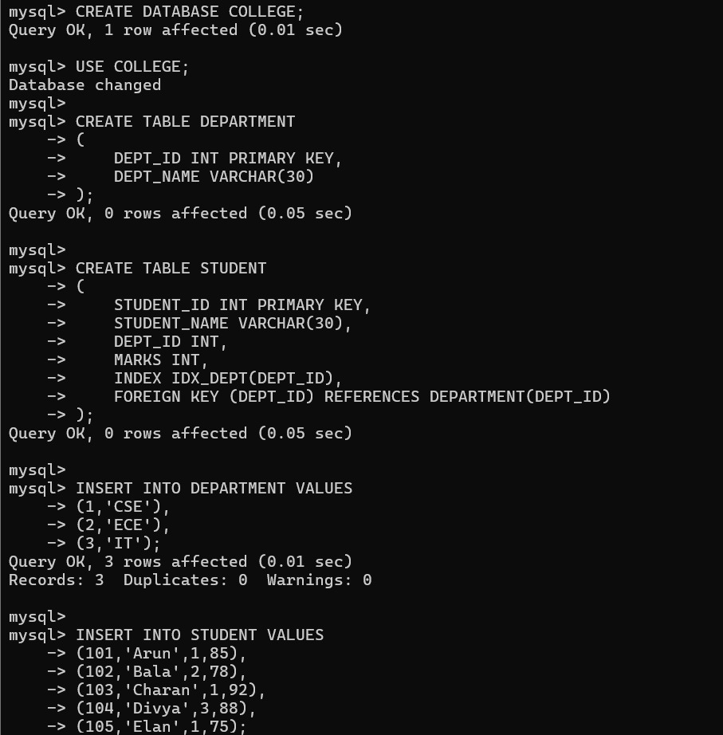

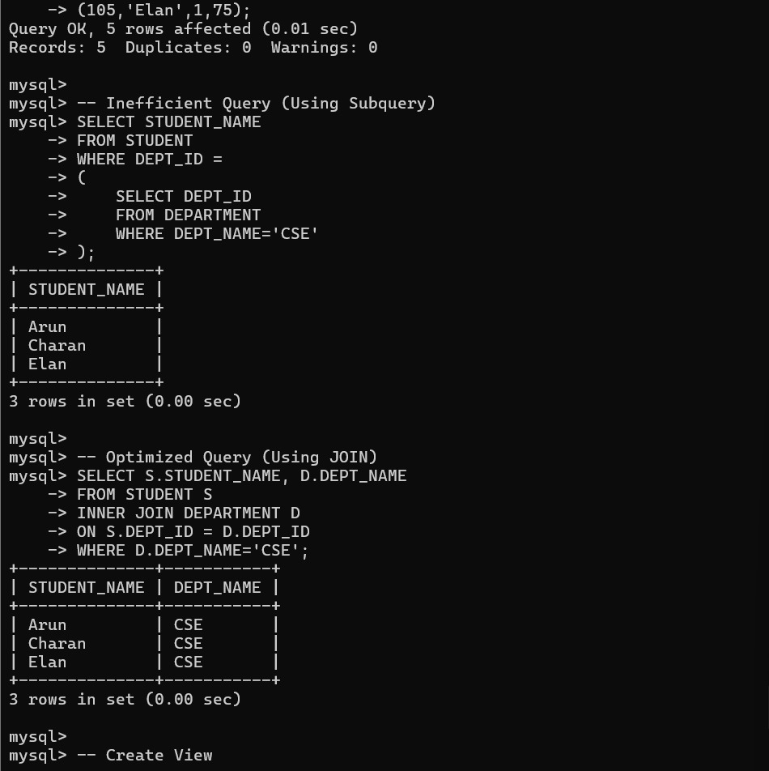

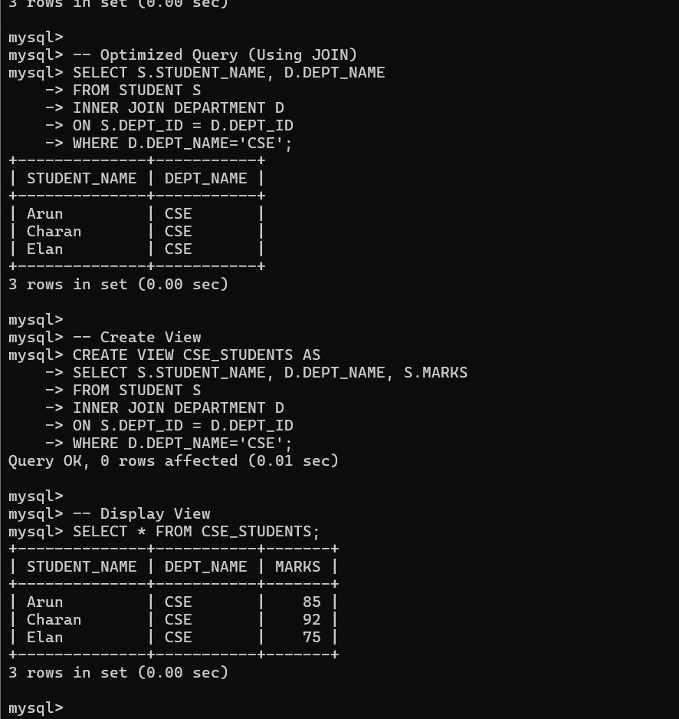

9.Develop a complex SQL query involving grouping, aggregation, and nested queries to solve a real-world problem.

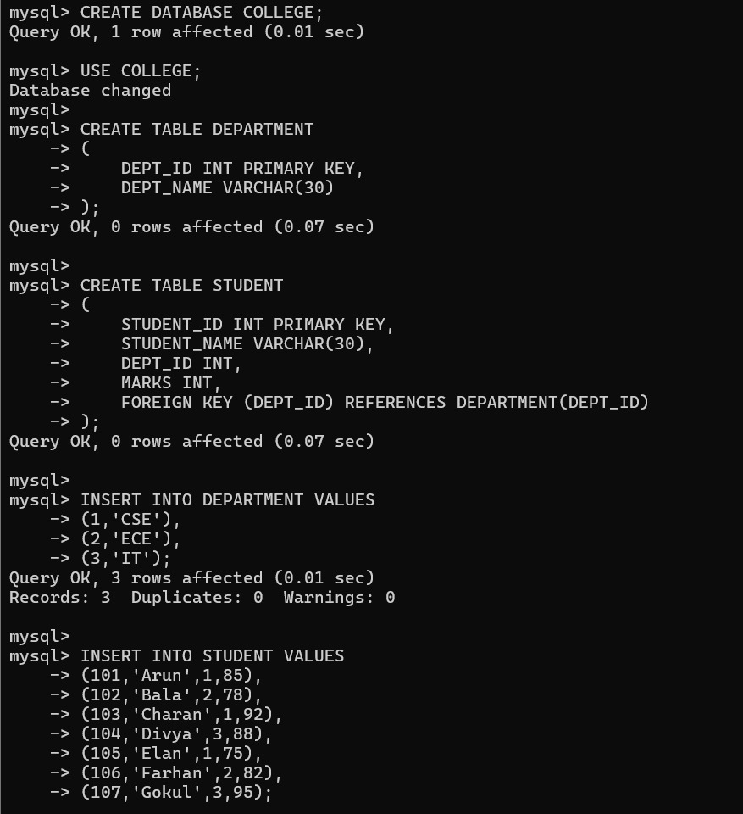

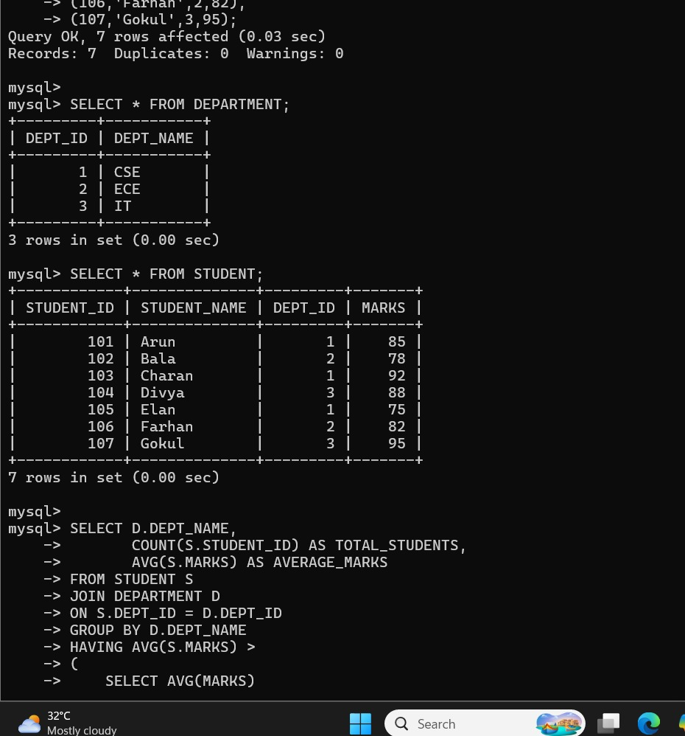

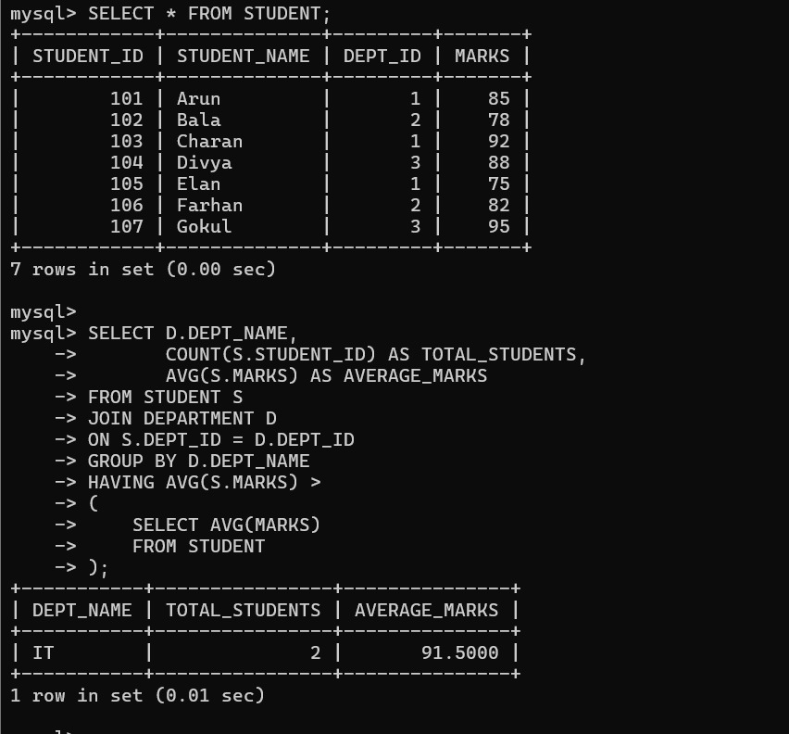

10.Given multiple relations, analyze the query requirements and decide whether to use views, joins, or subqueries, justifying your choice with reasoning.

